**CSE415 Milestone B Report**

by **Ziyuang Wang, Ye Jin**

We are trying to use hidden Markov model to predict the weather condition in local area. In our recent idea, there are three states of weather, they are sunny day, rainy day and snowy day. In the further work, we may add more complex weather conditions like windy day or cloudy day. The observable conditions that we use in this application is temperature, humidity and air pressure. The initial probability of next state is in **Figure 1**.

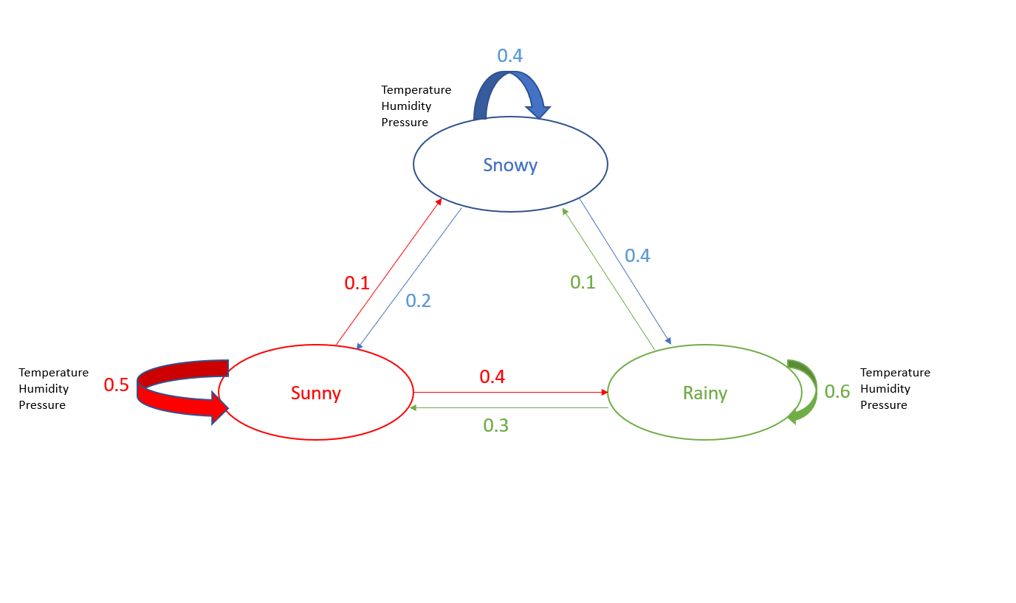

**Figure 1**

The whole problem is divided into three fundamental problems. First is the Likelihood, second Decoding and the last one, Learning. We are working on the first two problems, Likelihood and Decoding.

We are planning to divide the temperature, humidity and pressure into three levels, low, medium and high and working on the relationship between weather condition and temperature, humidity and pressure from the collected data. The weather data was collected from Internet, choose the past one month of temperature, humidity, pressure and weather condition of Seattle at 11.59am as a reference. Now we have a frame of code and pretty sure about our further work.